CRM Project

Functional Specification - Enhancement

PP6

(PP6) CM-090-160-060-E Contract Mgt Display Contract
(CM_ENH_400)

Deliverable Name | (PP6) CM-090-160-060-E Contract Display
Date | 12/01/2010
Revision | V1.0
Signed off By | Functional lead/PP6 Owner
Signoff Date

TABLE OF CONTENTS

1. Version 3
2. Approvals 3
3. Priority Mention the Priority of the object from the FRICEW list in ILM. N/A Processing Mode (check all that apply) 4
Low Medium High 4
4. Enhancement Requirements Description 4
5. Impacted Systems 4
6. Approach to be followed < List the type of enhancement whether it is a user exit, BADI or Custom transaction> 4
7. Roles and Volumes 4
8. Security & Control Requirements 5
8.1 Security Requirements 5
8.2 Control/Audit Requirements 5
9. Dependencies 5
9.1 Development Dependencies 5
9.2 Run/Execution Dependencies 6
9.3 Archiving Dependencies 6
10. Execution Steps 6
10.1 Process Description 6
10.2 Process Flow 6
10.3 As-Is Systems Referred To 7
10.4 Processing Options 7
11. Enhancement Description 7
11.1 Detailed Description of the Enhancement 8
The Display Contract process may be accessed only from the Contract Management default workcenter. The Contract related information will be viewed by selecting the Contract ID from the result list. In standard SAP CRM 7.0, the Details of Contract screen has 8 tabs Summary, Contract Data, Product, Service Location, Dates/Partners, Status, Billing Info and Cancellation Data. As part of this enhancement, details of the contract will only have 6 tabs as per following table: 8
11.2 UI Design and Screen Flow < Mention the WEBUI Design in the sense the mock up screens and the navigation flow between the screens etc> 16
11.3 Access Method or Path for Enhancement 17
11.4 Required Custom Tables (if known) 18
11.5 Error Handling Rules 18
12. Enhancement Reconciliation & Testing Requirements 18
12.1 Data Validation 18
Data validation will require the expected test cases execution and verifying the results based on business requirements. CRM project team along with their business support teams will be responsible to ensure this enhancement works. 18
12.2 Testing Reconciliation 18
12.3 Performance Issues 18
13. Additional Information 19
14. Open Items 19
15. Functional Unit Test cases 19
<Here they should list the possible test scenarios in the table below> 19

Version
Ensure that any approved change requests that affect scope are documented in the revision history and include CR #.
Version | Change Description | Author | Date Released | Sections Impacted
Enter in the version number | Brief description of the change | Who made the change | Date change was made | Mention the sections impacted with this change
1.1 | Document Creation | S Singh | 12/01/10
1.2 | Updates to source of data | S Singh | 02/14/10 | 11
1.3 | Updated Summary and Contract Data View to make Contract Data view as default view instead of Summary view.  Updated the table for Contract Data View with field ‘Request Reason’ for Security deposit  Updated The Product View tab and made the ‘Product Related Operands and Validity Dates’ as standard instead of enhancement. | S Singh | 04/14/10 | 11.1.1 and 11.1.2  11.1.2  11.1.3
1.4 | Update data retrieval logic for the following fields: Security Deposit, Security Deposit reason, and Joint Invoicing. | J Jarone | 5/7/2011 | 11.1.2

Approvals
The individuals listed below will be required to review and approve this document.
Reviewers Title | Reviewer Role | Name
Project Title of Reviewer | Reviewer’s Role (Responsible, Approve, Consult, Inform) | Reviewer’s Name
Technical Team Lead | Approve | V. Krishna Karunakaram
CRM Functional Team Lead | Approve | Robert Smeltekop  Bala Nair

Priority
Mention the Priority of the object from the FRICEW list in ILM.
N/A
Processing Mode (check all that apply)

Low Medium High
N/A

Enhancement Requirements Description
<This section should contain a detailed description of the business requirements for this enhancement in business terms. Please insert any description of the business flow which would aid in understanding this process.>

The user will be able to display the contract via the Contract Management default workcenter by selecting the individual contract.

Impacted Systems
<This list should include systems that are being impacted as a result of this enhancement.>

CRM 7.0 Web IC: CRM 7.0 Web Client Interaction Center Production System
ECC 6.0 / IS-U ECC 6.0 / IS-U: Back End Production System (Enterprise Central Component)

Approach to be followed
< List the type of enhancement whether it is a user exit, BADI or Custom transaction>
An enhancement will be required to Display the Contracts.

Roles and Volumes
<Describe information regarding users and volumes. Make sure to note if the use of this development will require additional communication and/or training. Also, specify what the volume requirements will be needed by the Go-Live date.

Complete the table below with the correct project-specific information for this functional specification. Instructions are in the middle row, and a sample entry is in the bottom row.>
Role | Estimated Volume Requirement | Comments
List name of role; should come from the list of security roles | Enter the estimated volume requirements that will be needed by the Go-Live date | Enter other comments including if this development will require additional communication and/or training
CSR 2 | 50 times per day
CSR 3 | 30 times per day
CSR 4 | 10 times per day
VCC MGMT | 50-60 times per day
BCOS | 15-20 times per day
Billing | + - 75 per day
Consumer Affairs | + - 15 per day
Revenue Recovery | + - 15 per day
Gas Trans | + - 15 per day

Security & Control Requirements

Security Requirements
<Describe any security requirements that need to be put in place as a result of this development object. This could include security access to affected transactions or new transactions that may result from this development. If the enhancement has to be archive enabled, list additional security to be added to the roles.>

This enhancement will be available to the following business roles:
CSR 2
CSR 3
CSR 4
VCC MGMT
BCOS
Billing
Consumer Affairs
Revenue Recovery
Gas Trans

Control/Audit Requirements
<Describe any control requirements that need to be put in place as a result of this development object>.
- If applicable, please answer the question and also provide detail to the question.
- The questions listed below are not all inclusive to the control requirement that may be required. If there are any other controls requirements please document them as well.

- Indicate if this enhancement is being developed to address a control requirement?
- Financial/SOX Impact – Does the enhancement have any impact to financial reporting? If yes, is the amount significant (i.e. greater than $35 million annually)? Please provide an estimate. No
- Regulatory Impact – Does the enhancement have any impact to regulatory compliance (i.e. FERC, NERC, etc)? If yes, please provide a reference to the rule and describe the impact. No
- Operational Impact – Is the enhancement relied upon for a mission critical process or providing services to customers? If yes, please identify the mission critical process and describe how this enhancement is used in the context of this process. No

Dependencies

Development Dependencies
<List the configuration, development, and other work that must be considered during the creation of this enhancement.>
This is dependent on New Contract creation being complete: CM-090-090-070-E Contract Mgt New Contract & Meter Data (CM_ENH_450)

Run/Execution Dependencies
<Once in production, this development object may need to be executed before or after another system event. List other system events that this development object should follow or precede. If the enhancement is to be archived enabled, does it need to have adequate archived sessions, info structures, etc established in order to test/execute.>
Business Partner, Premise and Business Agreement must be confirmed.

Archiving Dependencies
<List how the changes would impact archiving, if the enhancement impacts existing archived objects (i.e. table structures). Also list what needs to be regression tested from an archiving perspective.>
N/A

Execution Steps

Process Description
<Explain the process for when this development object will be used. If this is tied back to a certain task within a process you may insert the Task Profile document here as well.

Enter any of the following information available:
- Transaction Code
- User Exits
- Performance Consideration
- Z Tables created
- Code reuse.
This process may be accessed in the following way:

A user may click directly on Contract Management Work Center

Process Flow
<Create a diagram that visually depicts the process.>

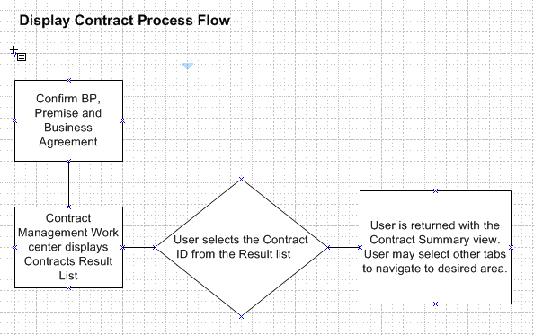

As-Is Systems Referred To
<List the systems that the task pertaining to this development object is performed in. If this is a new task (i.e. not being performed today), list it ‘Not applicable’.>

CRM 5.0 Win IC: Win Client Interaction Center – Production System
ECC 6.0 / IS-U ECC 6.0 / IS-U: Back End Production System (Enterprise Central Component)

Processing Options
<Indicate the Processing Mode, Frequency, and Lifetime of Development by selecting and placing an ‘X’ in the box next to the correct options below. Right click on the gray box, select properties, and specify “Checked”.>
Processing Mode (Select one of the following)
Batch Online – via Transaction Code Online – via Menu Path
On demand

Frequency (Select one of the following)
Daily
Weekly Quarterly
Monthly Annually
Other (If other, describe here)

Lifetime of Development (select one)
Permanent
Temporary, e.g. until rollouts are complete, specify details here

Enhancement Description
<Provide a brief description of the enhancement.>
The CRM 7 Web IC Contract Management provides access to display contracts replacing current Win IC FOPs.

Detailed Description of the Enhancement

The Display Contract process may be accessed only from the Contract Management default workcenter. The Contract related information will be viewed by selecting the Contract ID from the result list. In standard SAP CRM 7.0, the Details of Contract screen has 8 tabs Summary, Contract Data, Product, Service Location, Dates/Partners, Status, Billing Info and Cancellation Data. As part of this enhancement, details of the contract will only have 6 tabs as per following table:

Details of Contract Screen tabs | Standard or Enhancement | Displayed/Hidden
Summary | Standard | Displayed
Contract Data | Standard | Displayed
Product | Standard | Displayed
Product History | Enhancement | Displayed
Device Data | Enhancement | Displayed
Process Log | Enhancement | Displayed
Service Location | Standard | Hidden
Dates/Partners | Standard | Hidden
Status | Standard | Hidden
Billing Info | Standard | Hidden
Cancellation Data | Standard | Hidden

Display Contract will have Summary, Contract Data, Product, Product History, Devices Data and Process Log views as shown in the mock up screen below in the figure 11.1

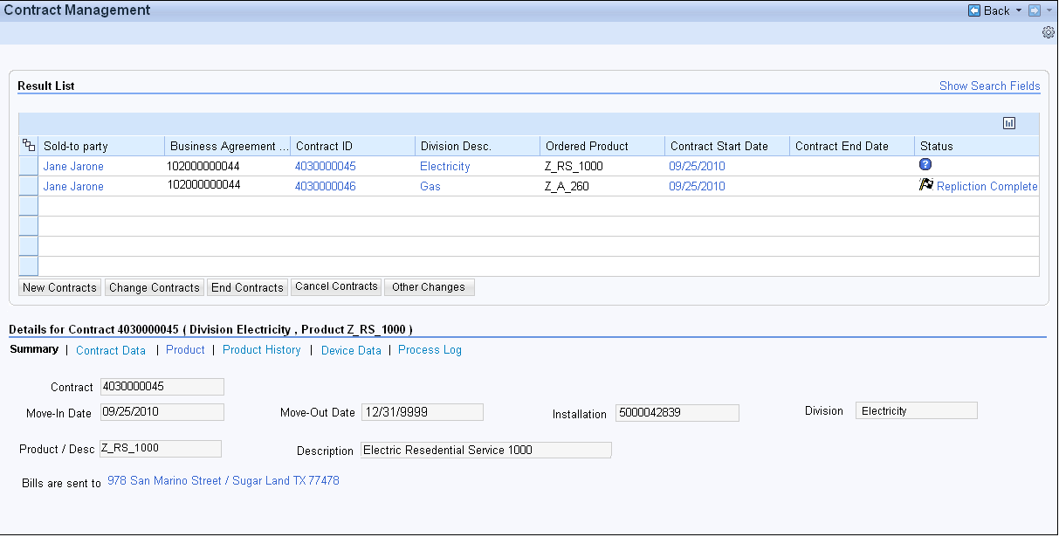
Contract Display Views Figure 11.1

11.1.1 Summary View

The Summary view is opened when the agent selects Summary tab as per mock up screen in figure 11.1.1


Contract Summary View Figure 11.1.1

The following standard UI Component and View need to be enhanced.

UI Component – IUICCOND

View – IUICCOND/SummaryShort

The view should be enhanced with the field placements as per the mock up screen in figure 11.1.1

The requirements for the fields (standard or enhancements) are identified in the table below:

Summary view fields | Standard or Enhancement | Displayed or Hidden
Contract | Standard | Displayed
Division | Standard | Displayed
Product /Desc | Standard | Displayed
Description | Standard | Displayed
Bills are sent to | Standard | Displayed
Request Start | Standard | Hidden
Request End | Standard | Hidden
Start Date | Standard | Hidden
End Date | Standard | Hidden
Status | Standard | Hidden
Paym. Made via | Standard | Hidden
Refunds paid to | Standard | Hidden
BPPlan Amount | Standard | Hidden
Balance Forward | Standard | Hidden
Sec. dep. Requ | Standard | Hidden
Request reason | Standard | Hidden
Alternative payer | Standard | Hidden
Refund recipient | Standard | Hidden

Note: The Move-in and Move-out date in the mock screen should be read as Contract Start Date and Contract End Date as per the Summary fields mentioned in the above table.

11.1.2 Contract Data View

The Contract view will be the default view when user selects Contract ID from the Contract Result list. The Contract Data view will be display the Contract related information. This view will have following fields as shown below in figure 11.1.2.1

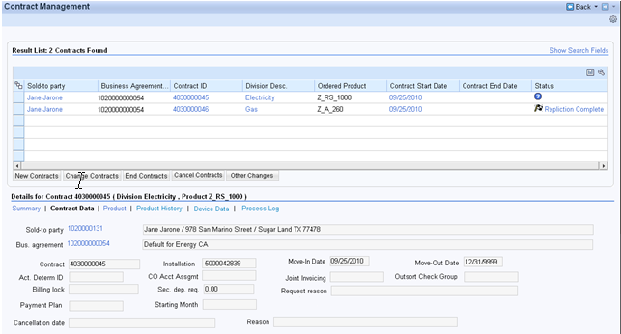
Contract Data View Figure 11.1.2.1

The following standard View needs to be enhanced for the Contract Data,

UI Component – IUICCOND

View - IUICCOND/ContractData

The view should be enhanced with the fields placement as per the mock up screen in figure 11.1.2.1

The requirements for the fields (standard or enhancements) are identified in the table below:

Contract Data view fields | Standard or Enhancement | Displayed or Hidden
Sold-to Party | Standard | Displayed
Bus. Agreement | Standard | Displayed
Contract | Standard | Displayed
Account Determination ID | Enhancement | Displayed
CO Acct Assgmt | Enhancement | Displayed
Joint Invoicing | Enhancement | Displayed
Outsort Check Group | Enhancement | Displayed
Billing Lock | Standard | Displayed
Sec. dep. Req. | Enhancement | Displayed
Request Reason | Enhancement | Displayed
Payment Plan | Enhancement | Displayed
Starting Month | Enhancement | Displayed
Cancellation Date | Enhancement | Displayed
Reason | Enhancement | Displayed
Installation | Enhancement | Displayed
Invoicing lock | Standard | Hidden
Campaign /Elm. | Standard | Hidden
Employee Responsible | Standard | Hidden

Sources of Data for Enhancement Fields:

Account Determination ID:

From ECC Table name: EVER (IS-U Contract)
Field: KOFIZ

CO Acct Assgmt:

From ECC Table name: EVER (IS-U Contract)
Field: COKEY

Joint Invoicing:

From ECC Table name: EVER (IS-U Contract)
Field: GEMFAKT

Outsort Check Group:

From ECC Table name: EVER (IS-U Contract)
Field: AUSGRUP

Sec. Dep. Req.:

The security deposit will be retrieved using function module Z_CALC_SECURITY_DEP_REQ_TOTAL.

Sec. Dep. Req Reason
Logic for security deposit reason :
1) Get security deposit number(SECURITY) from FKK_SEC_C table by passing contract number to VTREF field
2) Get security deposit reason(REASON) from FKK_SEC table by passing security deposit number to SECURITY field
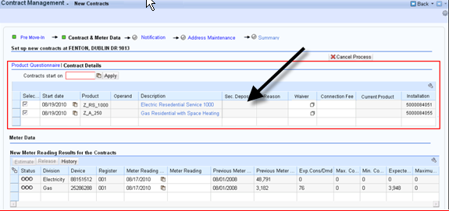

Payment Plan:

From ECC Table name: EVER (IS-U Contract)
Field: PYPLT

Starting Month:

From ECC Table name: EVER (IS-U Contract)
Field: PYPLS

Cancellation Date:

From ECC Table name: EVER (IS-U Contract)
Field: KUENDDAT

Reason:

From ECC Table name: EVER (IS-U Contract)
Field: CANCREASON_NEW

11.1.3 Product View

The Product View displays Product, Description, Details and Product Related Operands and Validity Dates as shown below in figure 11.1.3.

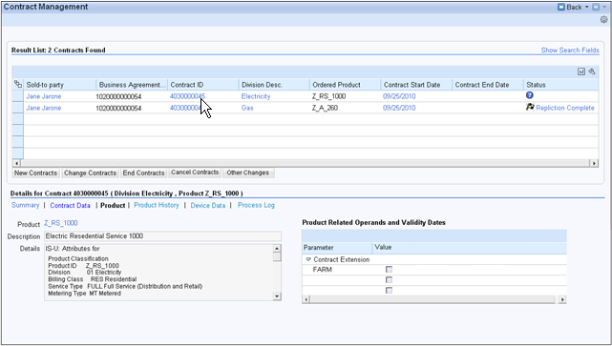
Product View Figure 11.1.3

This following standard view in Contract Display should be enhanced to include the fields and their placement on the view as per the mock up screen in figure 11.1.3.

UI Component - IUICCOND

View - IUICCOND/Product

The requirements for the fields (standard or enhancements) are identified in the table below:

Product view fields | Standard or Enhancement | Displayed or Hidden
Product | Standard | Displayed
Description | Standard | Displayed
Details | Enhanced as per Product Classification Data (below) | Displayed
Product Related Operands and Validity Dates | Standard | Displayed

The Product Details should only display the Product Qualification Data (as per the mock up screen in figure 11.1.3) with following information. These are available SAP standard data on this view.

Product Classification
Product ID
Division
Service Type
Metering Type
Billing Class
Product Type
Status
Voltage Level
Voltage Service

11.1.4 Product History View

The following PP6 document should be referred to design the Product History View:

PP6 document CRM.PP6.CM-050-050-080-E.CM_ENH_060.Product History View,

11.1.5 Device Data View

The following PP6 document should be referred to design the Device Data View:

PP6 document CRM.PP6.CM-050-050-130-E.BO_ENH_940 Display rate data at Device and register level

11.1.6 Process Log View

The Process Log view displays change history related to the contract as per the mock up screen shown below in figure 11.1.6.

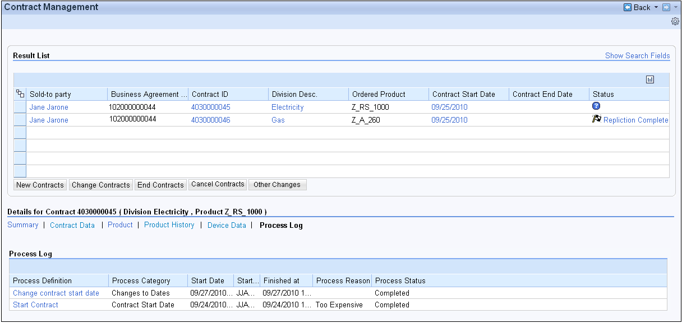
Process Log View Figure 11.1.6

This is standard SAP UI Component and View:

Component: IUPRMAIN

View: IUPRMAIN/ProcessLog

The Process log view will have following fields:

- Process Definition
- Process Category
- Start Date
- Started By
- Finished at
- Process Reason
- Process Status

UI Design and Screen Flow
< Mention the WEBUI Design in the sense the mock up screens and the navigation flow between the screens etc>

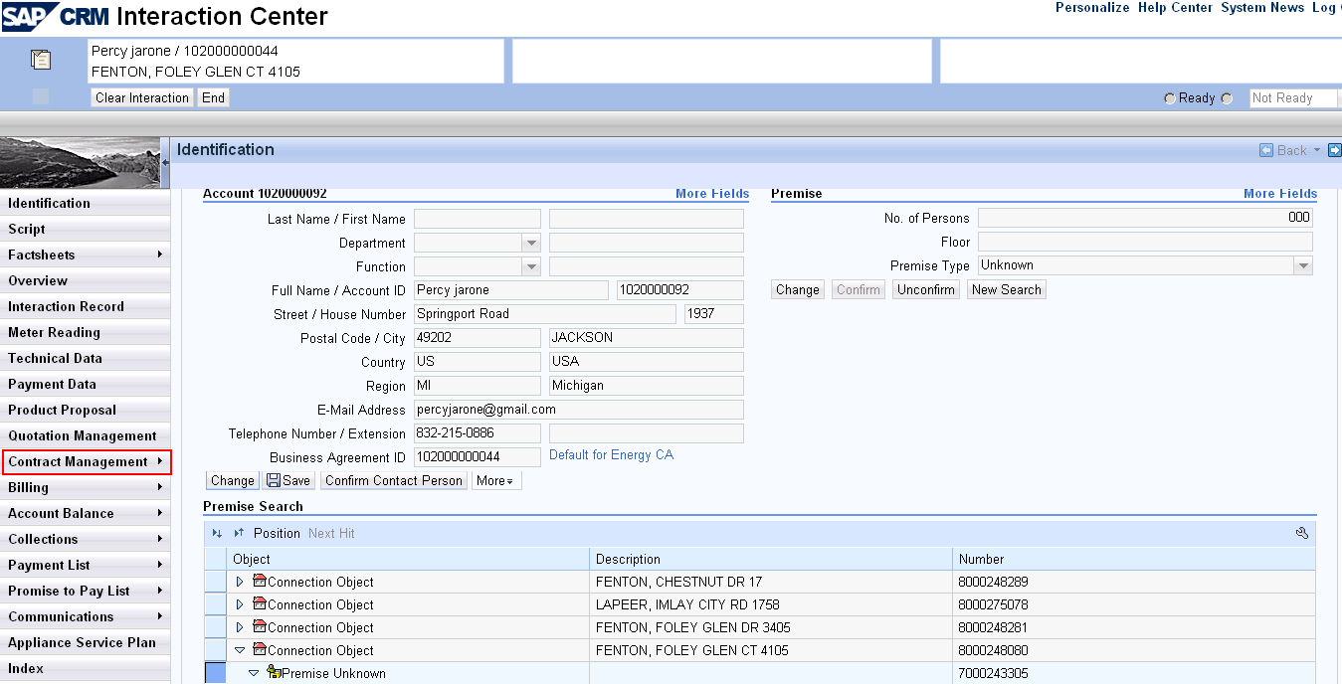

Contract Management Navigation Bar – figure 11.2.1

Contract Display Tabs –figure 11.2.2

Access Method or Path for Enhancement
<Select the correct execution path below by placing an ‘X’ in the checkbox next to it and completing the description that follows. Check all that apply and add any other execution methods if required by the Client. Right click on the gray box, select properties, and specify “Checked”.>
Execution: Custom Transaction Code:
Menu Path:
Standard Transaction Code:
Other: CRM 7.0 Web IC Navigation

Required Custom Tables (if known)
<Provide any information about custom tables required for this enhancement.>
Table Name: Enter Table Name
Table Description: Enter Table Description
M/O | Field Description | Type (text or numeric) | Maximum Field Length | Value Restrictions? | Validations?
Mention M if the field is mandatory and O if the field is optional | Enter the field description | Enter the type | Enter the max. field length | Enter any value restrictions | Mention if any validations are required or else mention NA

Error Handling Rules
<Explain what the error handling rules would be if there are any for this development. For example, if an enhancement is scheduled to be printed and it does not, what should a user do to get this corrected?>

MSG No. | MSG Type | CRM 7.0 System Messages
010 | Error | Message: Please Confirm BP and Premise
020 | Error | Message: Please Confirm Business Agreement

Enhancement Reconciliation & Testing Requirements

Data Validation

Data validation will require the expected test cases execution and verifying the results based on business requirements. CRM project team along with their business support teams will be responsible to ensure this enhancement works.

Testing Reconciliation
This enhancement will be tested by the teams (their security roles) who need to access the Contracts. Team will include CRM Project Team, BTS Support Team, Call Center, BCOS, Revenue Recovery, Consumer Affairs and Billing.

Performance Issues
N/A

Additional Information
N/A

Open Items
<This includes Risks and Issues logged in Clarity and Action Items.>
Item # | Detailed Description | Proposed Solution
Insert number | Describe the item | Describe the proposed resolution

Functional Unit Test cases

<Here they should list the possible test scenarios in the table below>
Test Condition Description | Input Data | Expected Results | Actual Results/Comments
Select Contract Management Workcenter in the navigation bar. |  | Result List should appear with a list of Contracts for the Business Partner and Premise confirmed.
Select Contract ID from the Result list and verify the tabs and fields on Summary tab |  | The Summary view of the selected Contract should be displayed as the default view.  Verify the fields and data displayed for the fields on the Summary view.
Select Contract Data tab and verify the fields |  | The Contract Data view of the selected Contract should be displayed.  Verify the fields and data displayed for the fields on the Contract Data view:
Select Product tab and verify the fields |  | The Product view of the selected Contract should be displayed.  Verify the fields and data displayed for the fields on the Product view.
Select Product History tab and verify the fields |  | The Product History view of the selected Contract should be displayed.  Verify the fields and data displayed for the fields on the Product History view.
Select Device Data tab and verify the fields |  | The Device Data view of the selected Contract should be displayed.  Verify the fields and data displayed for the fields on the Device Data view.
Select Process Log tab and verify the fields |  | The Process Log view of the selected Contract should be displayed. It should display the change history related to the Contract.

